AZURE ELASTIC SAN

Azure Elastic SAN :

Azure Elastic SAN is a cloud-native Storage Area Network (SAN) that provides scalable, high-performance block storage for various enterprise workloads.

Features :

Scalable, Block storage, Elastic, Fully managed, Low latency.

Use cases :

* Storing disks for hundred or thousands of azure virtual machines.
* Replacing On-premises SAN infrastructure with cloud – native equivalent.

App

App

App

OS

OS

OS

Hypervisor

OS

OS

OS

Hypervisor

Server

App

OS

Server

Hypervisor

Physical Server Virtualization Cloud

Azure VMware Solution :

Azure VMware Solution allows you to run VMware workloads natively in Azure. It provides a dedicated private cloud environment built on VMware Cloud Foundation (vSphere, HCX, NSX, and vSAN) running on Azure bare-metal infrastructure.

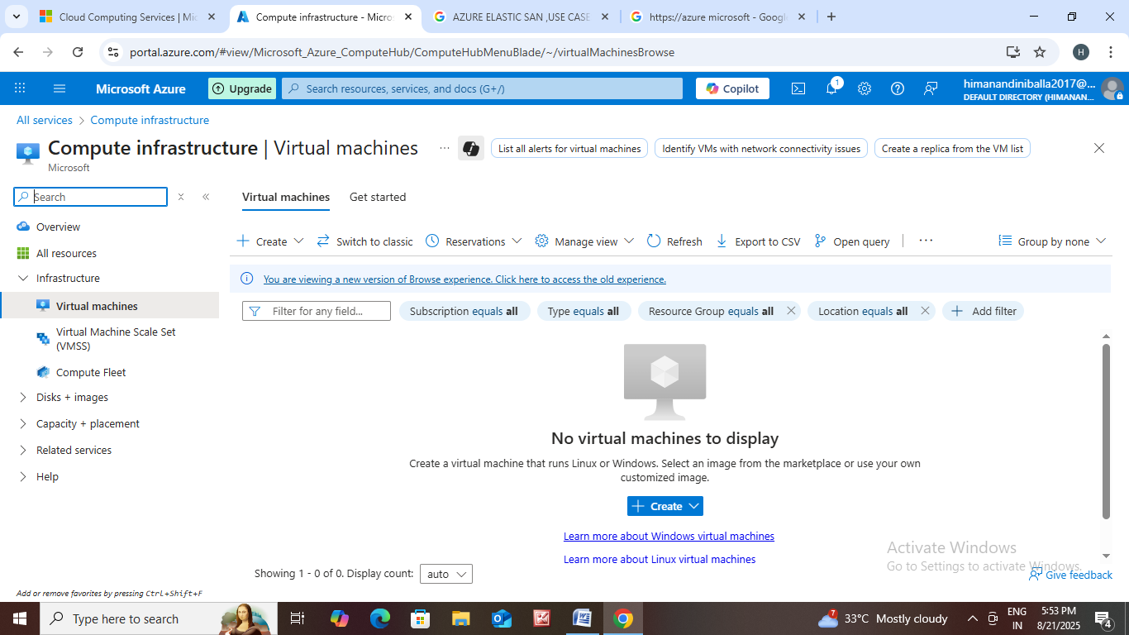How to create Virtual machine ?

Go to https://azure Microsoft.com.

* Go to all services.
* Then click on virtual machines.
* The page is open then click on create.
* Resource group : click on new then create resource group ex :Elasticsan-rg.
* Virtual machine name : mydbserver.
* Region : (us) east us you can choose which region you want.
* Availability zone : Zone 1
* Security 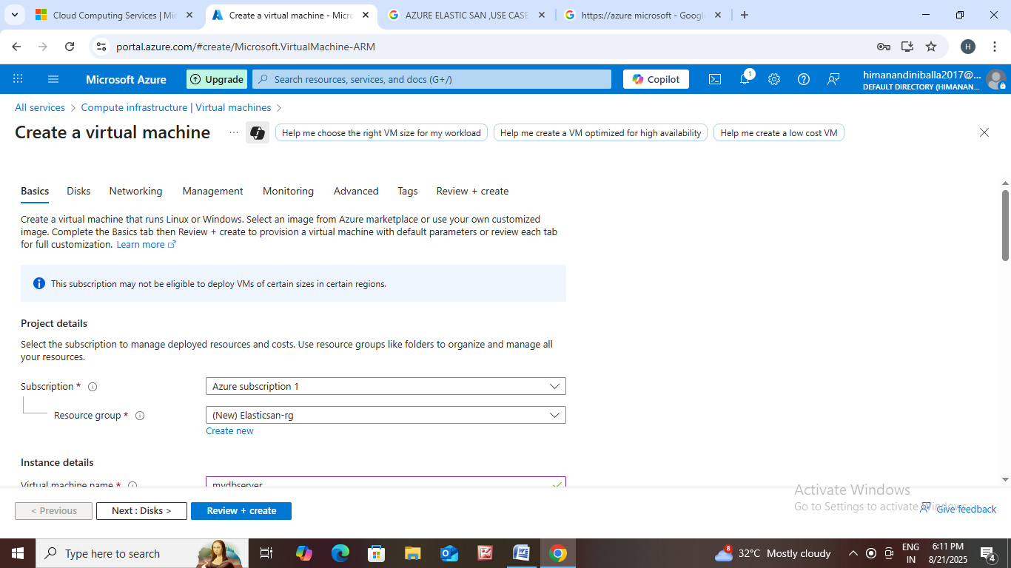type : Trusted launch virtual machine
* Select image in it.
* Select size.
* In administrator account enter your username, password.
* Allow selected ports.
* Then click on next.
* In networking click on new ip address.
* Give some name for that ex:mydbserver-ip.
* Then click on create.

How to create an Elastic SAN?

* 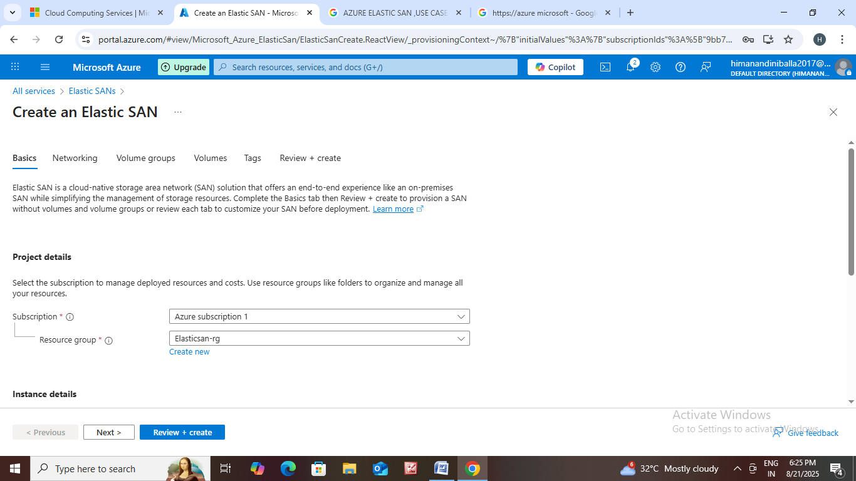Go to all services.
* Click on Elastic SAN.
* Resource group – Elasticsan-rg.
* Elastic SAN name : amazonsan
* Redundancy : Zone – redundantstorage
* We canselect which base you want.
* Then click on next.
* Public network access : enable
* Then create volume name as mobilevolumegroup.
* Click next then create virtual network.
* Create 2 volumes.
* Then name the tag.
* Then click on create.